Andrew Alferman

MTH 552

Homework #4 (Corrected)

Due Wed, Feb 15, 2017 (Corrections due 12:00PM Sun, Feb 19, 2017)

1) The attached MATLAB code has been modified as directed. The code allows for either fixed stepsize or automatic stepsize to be selected, depending if the value assigned to “autostep” is true or false. The “method” variable represents the numerical method to be used; 'RK1' and 'ExplicitEuler' represent the Euler method, 'RK4' represents the RK method from problem 2 of Assignment 2, and 'HW2' represents the RK method from problem 2 of Assignment 2 (modified per email on 2/14/17). The “steps” global variable counts how often the function f is being evaluated.

A tolerance of 1x10-4 was selected because it yielded plot of u1 versus u2 that was approximately correct visually for all three methods evaluated. A tolerance value of 2x10-4 with the HW2 method yielded a plot that was noticeably distorted near the completion of the first orbit, while the HW2 method and RK4 methods yielded acceptable plots at that tolerance value. The RK4 plot appeared slightly jagged in some portions of the orbit due to the small number of steps used. The code output the figures below. The number of steps can be found on each plot (7863, 1254, and 339 for RK1, HW2, and RK4, respectively). All three methods came up with comparable plots, however the RK4 method was faster than the other two methods. On the computer used to produce the figures, the RK1 compiled in approximately 0.544 seconds (decreased to 0.496 when using the “ExplicitEuler” function), the HW2 method compiled in 0.311 seconds, and the RK4 method compiled in 0.284 seconds. The RK4 method appeared to be fastest, though all computation times were very similar and the results may vary based on background program usage.

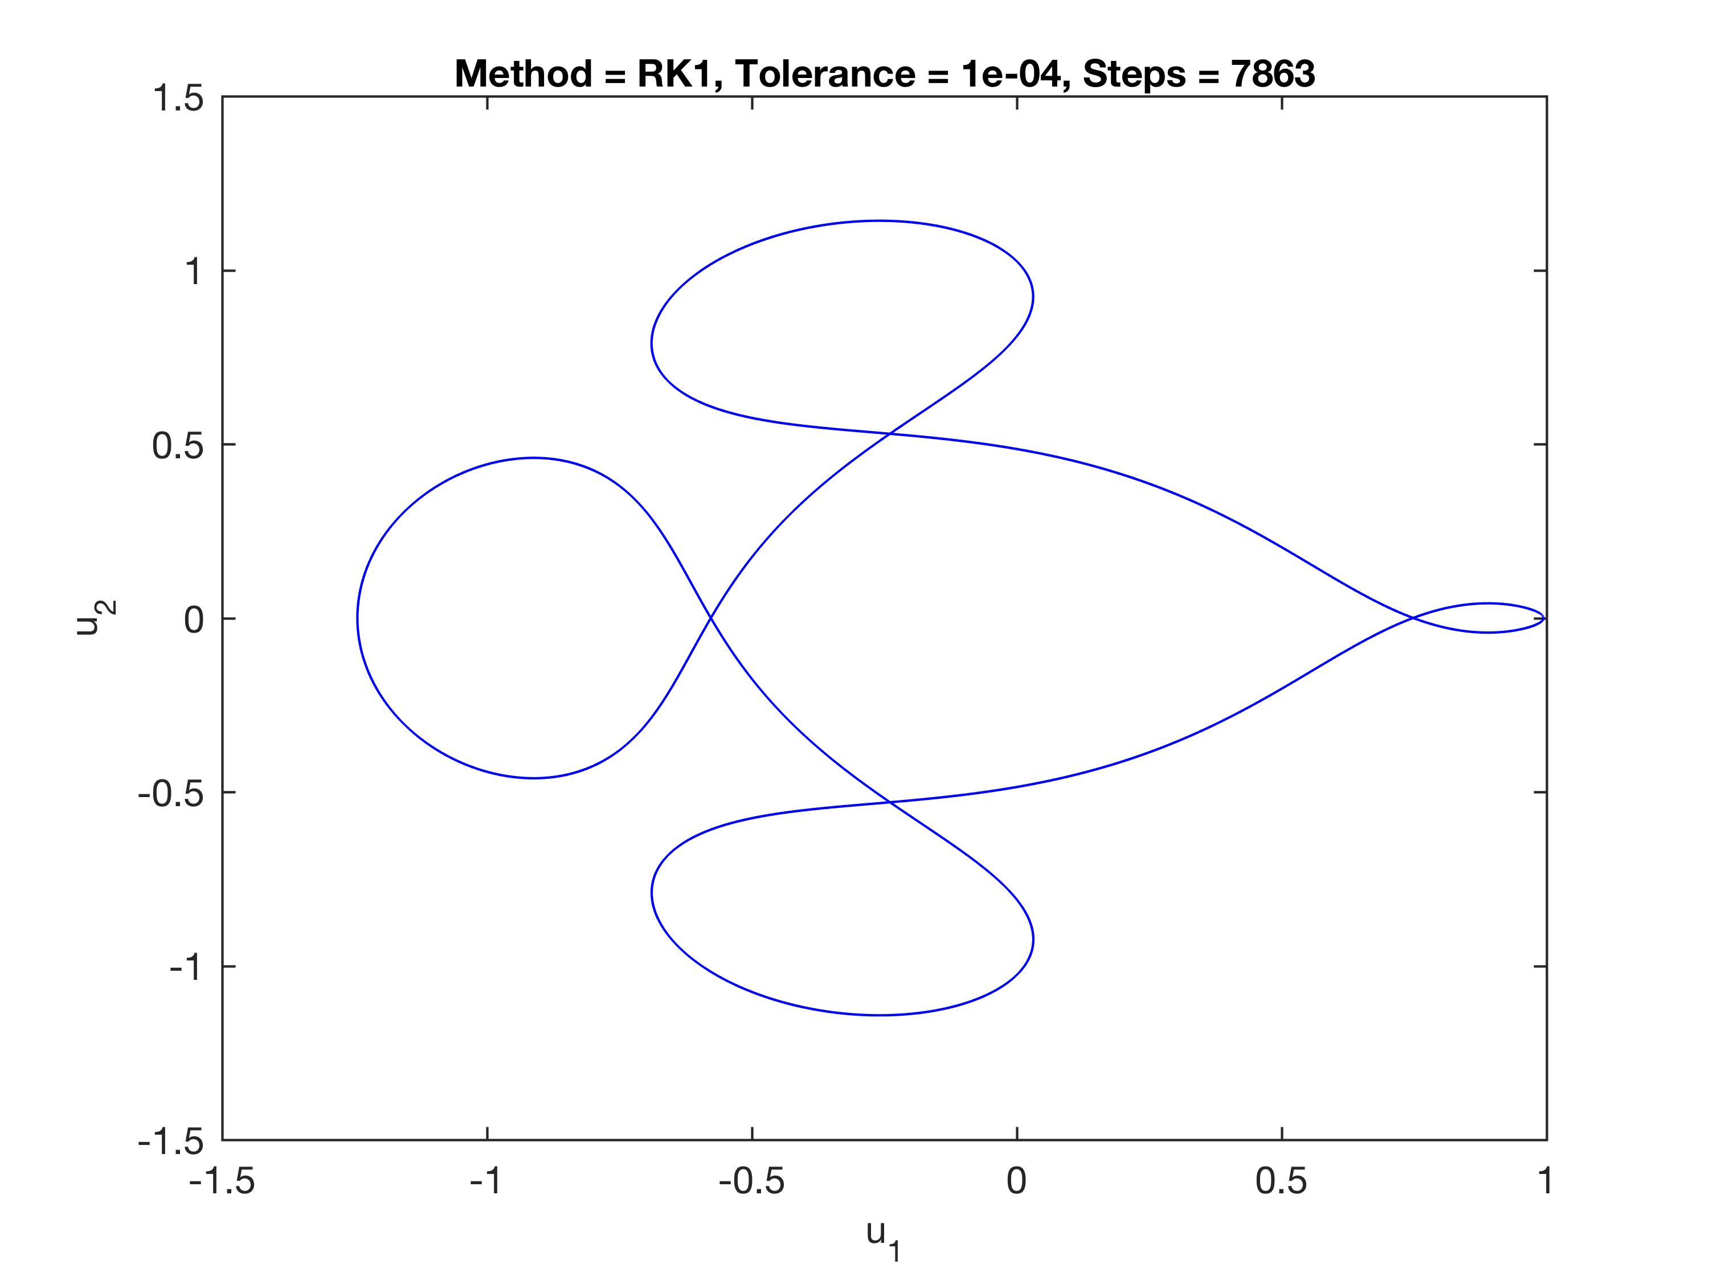

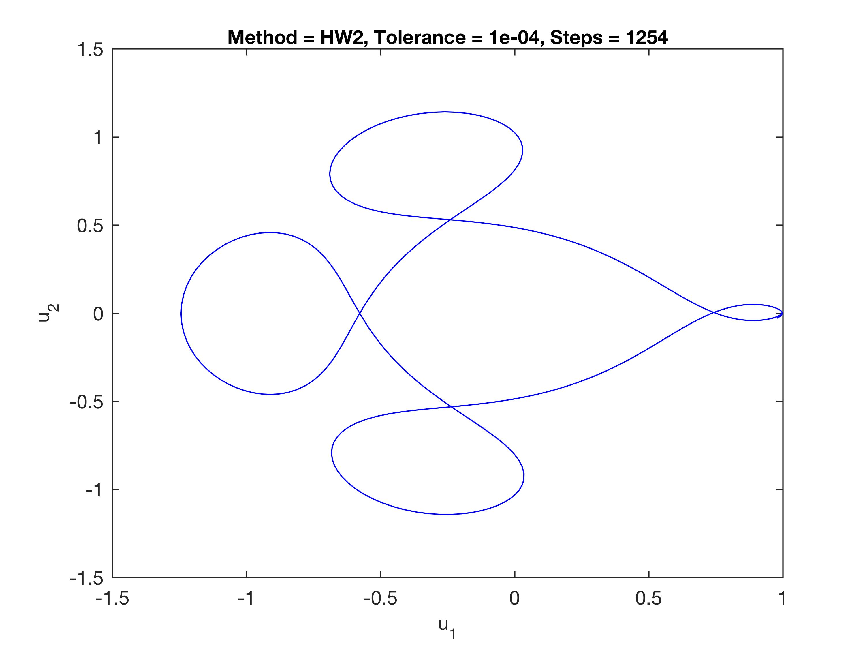

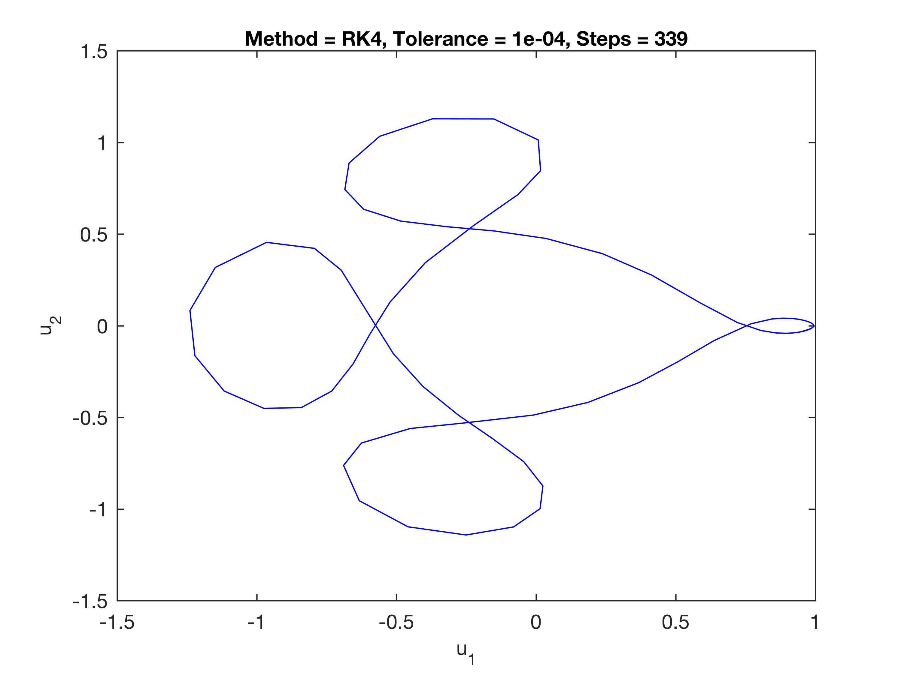

2) The attached code has been modified was modified as directed. At first, it appears as if the solution to the IVP is completely flat for -1 ≤ t ≤ 0, while each of the curves for 0 < t ≤ 1 are different for each of the tolerances that were evaluated. This result is illustrated below:

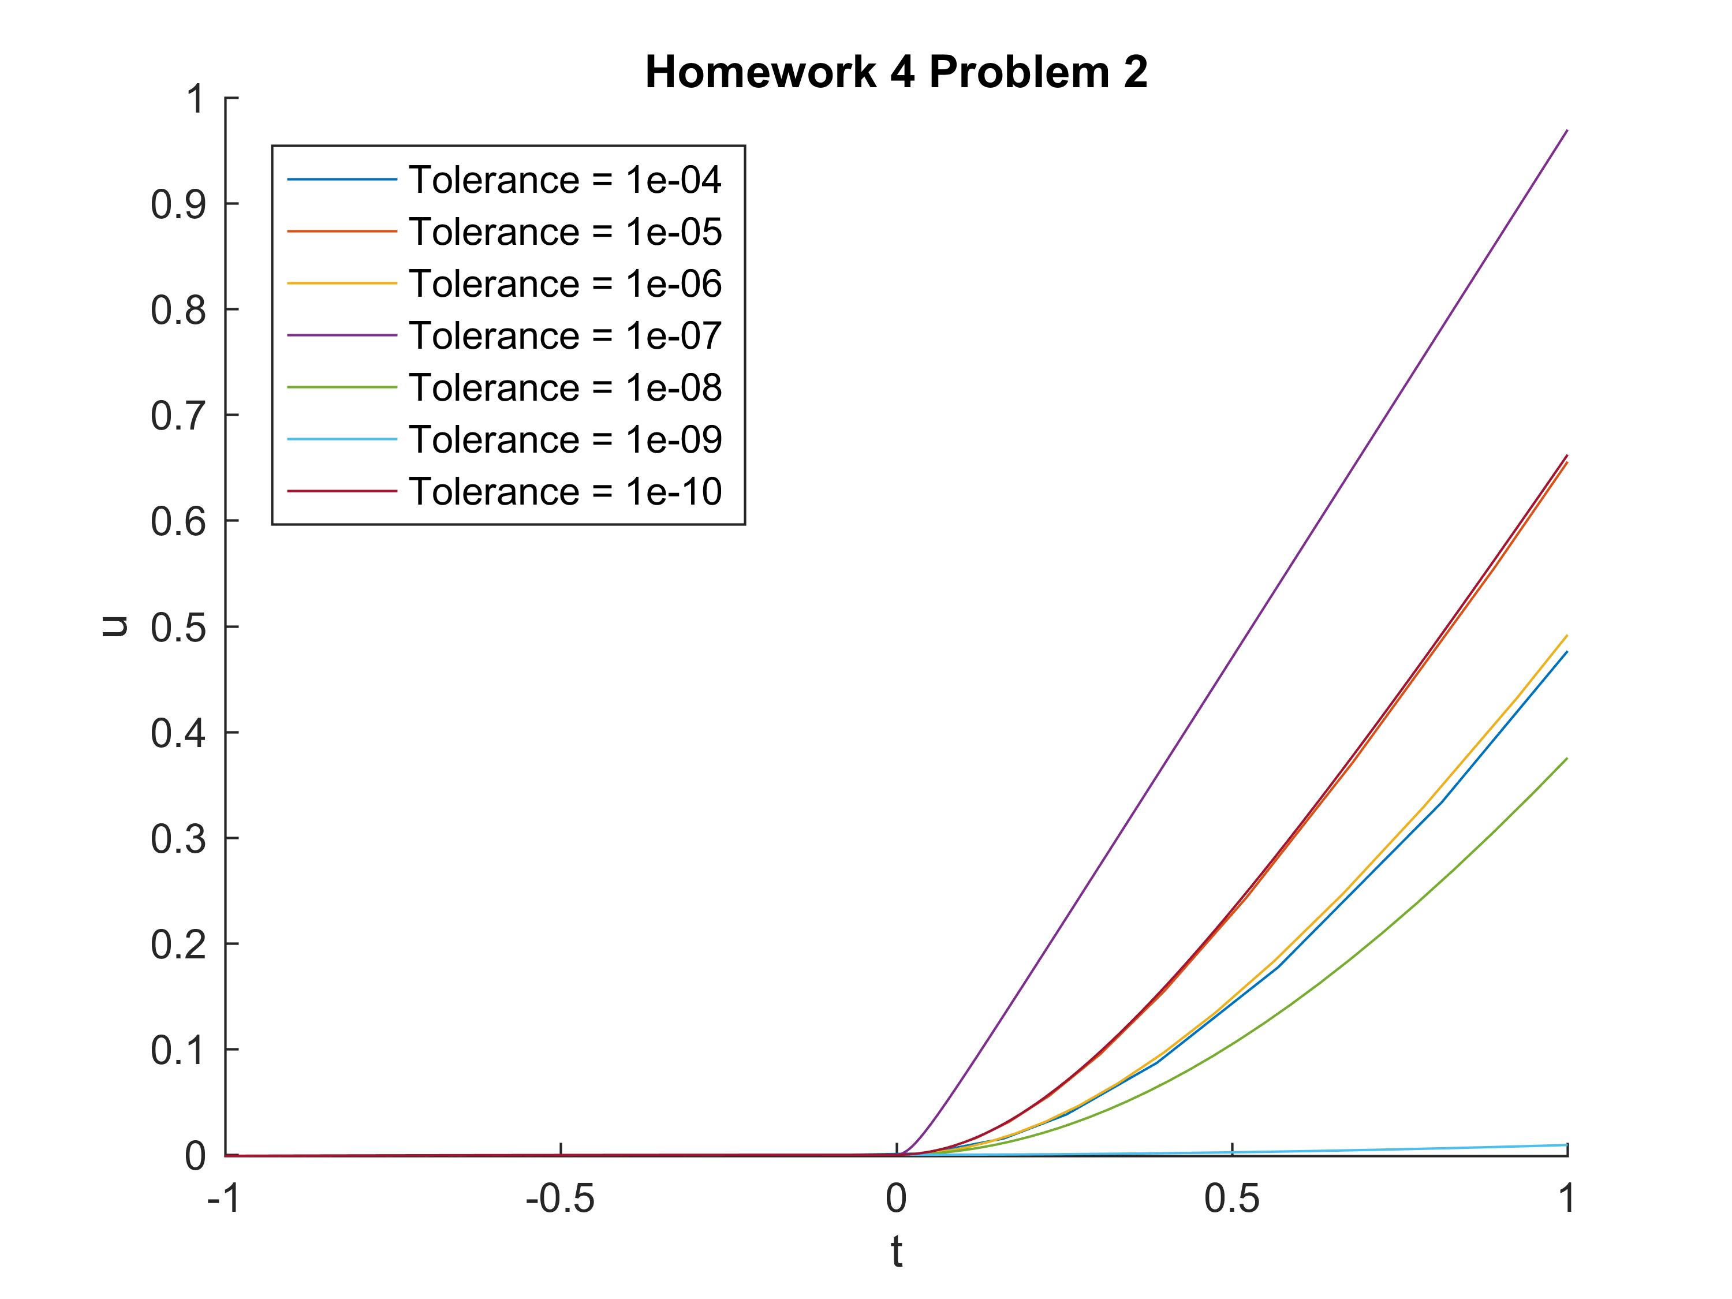

Upon closer inspection, by limiting the y axis to -0.001 ≤ u ≤ 0.001 it can be seen that the IVP converges from -1 ≤ t < 0, and the solution blows up when 0 ≤ t. The results do not converge when 0 ≤ t because there is a discontinuity at t = 0 which “breaks” the numerical method (the existence and uniqueness theorem with a global Lipschitz condition isn't satisfied).

